Solution to 2018 Paper B

1. Multiple Choice (2 points for each, 16 points in total)
1-1 Which of the following temperature is the lowest one:
(A) 0.0℃;
(B) 0.0℉;
(C) 4.2K；
(D)-195.8℃.

Answer: (C)
To compare these temperatures, convert them all to Kelvin scale.
For (A) the Kelvin temperature is TK=Tc+273.16K=273.16K;
for (B)
;
for (C) TK=4.2K;
for (D) TK=Tc+273.16K= -195.8+273.16K=77.4K.

1-2 Which gas has highest root mean square speed of molecules:
(A) oxygen (M = 32.0 g/mol) at 300 K;
(B) nitrogen (M = 28.0 g/mol) at 300 K;
(C) oxygen at 330 K;
(D) nitrogen at 330 K.

Answer: (D)
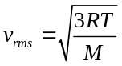,
so the root mean square speed is proportional to the square root of the ratio of absolute temperature T to molar mass M.

1-3 You want to cool a storage chamber containing 10 moles of compressed gas from 30℃ to 20℃. For which kind of gas would this be easiest?
(A) a monatomic gas;
(B) a diatomic gas;
(C) a polyatomic gas;
(D) it would be equally easy for all of these.

Answer: (A)
For a given number of moles n and a given temperature change 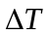, the amount of heat that must be transferred out of a fixed volume of air is 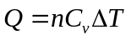. Hence the amount of heat transfer required is least for the gas with the smallest value of 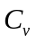. The value of is smallest for monatomic gases.

1-4 Your left and right hands are normally at the same temperature. Is rubbing your hands together to warm them
(A) a reversible process
(B) an irreversible process?

Answer: (B)
Like sliding a book across a table, rubbing your hands together uses friction to convert mechanical energy into heat. The (impossible) reverse process would involve your hands spontaneously getting colder, with the released energy forcing your hands to move rhythmically back and forth.

1-5 To double the total energy for a mass-spring system oscillation in SHM, by what factor will the frequency change due to this amplitude increase?
(A) 4;
(B) 2;
(C) 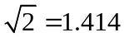;
(D) it does not change.

Answers: (D)
Because the motion is SHM, changing the amplitude has no effect on the frequency.

1-6 The six strings of a guitar are the same length and under nearly the same tension, but they have different thickness. On which string do waves travel the fastest?
(A) the thickest string;
(B) the thinnest string;
(C) the wave speed is the same on all strings.

Answer: (B)
The relationship 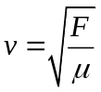 says that the wave speed is greatest on the string with the smallest linear mass density. This is the thinnest string, which has the smallest linear mass density μ=m/L (all strings are the same length).

1-7 Four identical strings each carry a sinusoidal wave. The string tension and wave amplitude are different for different strings. Which of the following strings has highest average wave power?
(A) frequency 10 Hz, amplitude 1.0 mm;
(B) frequency 20 Hz, amplitude 1.0 mm;
(C) frequency 10 Hz, amplitude 3.0 mm;
(D) frequency 20 Hz, amplitude 2.0 mm.

Answer: (D)
Equation (15.25) says that the average power in a sinusoidal wave on a string is 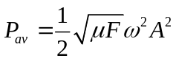.
Average wave power directly proportional to the square of frequency and amplitude.

1-8 What minimum number of slits would be required in a grating to resolve the sodium doublet in the fourth order?
(A) 250;
(B) 400;
(C) 1000;
(D) 4000.

Answer: (A)
As described in the text, the resolving power needed is R=Nm=1000. In the first order (m=1) we need N=1000 slits, but in the fourth order (m=4) we need only N=R/m=1000/4=250 slits. (These numbers are only approximate because of the arbitrary nature of our criterion for resolution and because real gratings always have slight imperfections in the shapes and spacings of the slits.)

2. Completion ( 3 points for each, 24 points in total)

2-1 A 25,000-kg subway train initially traveling at 15.5 m/s slows to a stop in a station and then stays there long enough for its brakes to cool. The station’s dimensions are 65.0 m long by 20.0 m wide by 12.0 m high. Assuming all the work done by the brakes in stopping the train is transferred as heat uniformly to all the air in the station, by how much does the air temperature in the station rise? . Take the density of the air to be 1.2 kg/m³ and its specific heat to be 1020 J/kg·K.

Solution:
The work done by the brakes equals the initial kinetic energy of the train.
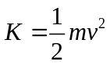
The initial kinetic energy of the train is K=0.5×(25,000 kg)(15.5 m/s)²= 3.00×10⁴ J.
Therefore, Q for the air is 3.00×10⁴ J.
m=ρV=(1.20 kg/m³)(65.0 m)(20.0 m)(12.0 m) = 1.87×10⁴ kg.
Q=mcΔT gives
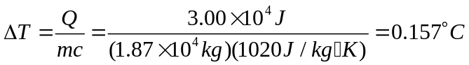
The mass of air in the station is comparable to the mass of the train and the temperature rise is small.

2-2 A system is taken from state a to state b along the three paths shown in the following figure.
If U_{a} > U_{b} , along which path is the absolute value |Q| of the heat transfer the greatest?

a
b
1
2
3
V
P
O

Solution:
Apply ΔU = Q –W.
|W| > 0 when V increases.
The greatest work is done along the path that bounds the largest area above the V-axis in the P-V diagram, which is path 1.
W > 0 in all three cases.
ΔU is the same for all three path.
Q = ΔU + W , so Q > 0 for all three, with the greatest for the greatest work, that along path 1.

2-3 A Carnot engine whose low temperature reservoir is at -90.0℃ has an efficiency of 40.0%. An engineer is assigned the task of increasing this to 45.0%. By how many Celsius degrees must the temperature of the low temperature reservoir be decreased if the temperature of the high temperature reservoir remains constant?

Solution:
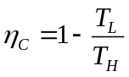, 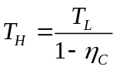 T_{L}= -90℃=183.16K
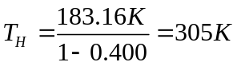
For η_{C}=45.0%, T_{L} = (1-η_{C})T_{H} = (1-0.450)(305K)=168K.
T_{L} must be decreased by 15K = 15℃

2-4 A block with mass M rests on a frictionless surface and is connected to a horizontal spring of force constant k. The other end of the spring is attached to a wall. A second block with mass m rests on top of the block. The coefficient of static friction between the blocks is μ_{s} .What is the maximum amplitude of oscillation such that the top block will not slip on the bottom block.

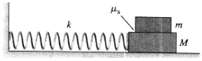
Solution:
The maximum acceleration of the lower block can’t exceed the maximum acceleration that can be given to the other block by the friction force.
For block m, the maximum friction force is
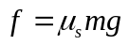
So, 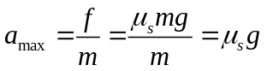
For the simple harmonic motion of the two blocks together,
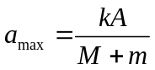
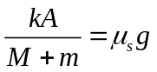
Therefore, 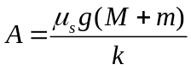

2-5 Two waves traveling along a stretched string have the same frequency, but one transports three times the power of the other. What is the ratio of the amplitudes of the two waves?

Solution:
Because the speed and frequency are the same for the two waves, the intensity and thus the power depends on the amplitude:
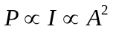
For the ratio of intensities we have
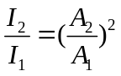
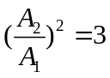, which gives 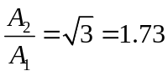

2-6 Two coherent sources A and B of radio waves are 5.00 m apart. Each source emits waves with wavelength 6.00 m. Consider points along the line between the two sources. At what distances, if any, from A is the interference constructive?

Solution:
Compare the path difference to the wavelength.
The separation between sources is 5.00 m, so for points between the sources the largest possible path difference is 5.00 m.
For constructive interference the path difference is
δ= mλ, m=0, ±1, ±2,…
Since λ=6.00m, only the path difference of zero is possible.
This occurs midway between the two sources, 2.50 m from A.

2-7 When viewing a piece of art that is behind glass, one often is affected by the light that is reflected off the front of the glass (called glare), which can make it difficult to see the art clearly. One solution is to coat the outer surface of the glass with a film to cancel part of the glare. If the glass has a refractive index of 1.62 and you use TiO₂, which has an index of refraction of 2.62, as the coating, what is the minimum film thickness that will cancel light of wavelength 505 nm?

Solution:
Require destructive interference for light reflected at the front and rear surfaces of the film.
At the front surface of the film, light in air (n=1.00) reflects from the film (n=2.62) and there is a π phase shift due to the reflection. At the back surface of the film, light in the film (n=2.62) reflects from glass (1.54) and there is no phase shift due to reflection. Therefore there is a net π phase difference produced by the reflections.
For destructive interference, we have
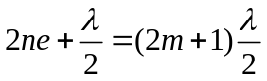, m=1, 2, 3…
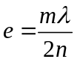, m=1, 2, 3…
The minimum thickness is 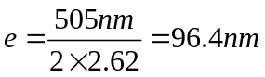

2-8 An astronaut in orbit can just resolve two point sources on the earth that are 75.0 m apart. Assume that the resolution is diffraction limited, the diameter of his pupil is 4.00 mm and the wavelength of the light is 500 nm. What is the astronaut’s altitude above the earth?

Solution:
Resolved by Rayleigh’s criterion means the angular separation of the objects is given by
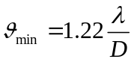
The distance between the two objects is L=75.0 m.
The distance of the objects from the astronaut (his altitude) is S.
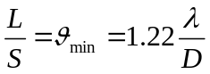
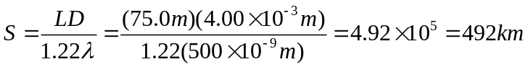

3. Problems (10 points for each, 60 points in total)

3-1 While running, a 70-kg student generates thermal energy at a rate of 1200 W. To maintain a constant body temperature of 37℃, this energy must be removed by perspiration or other mechanisms. If these mechanisms failed and the heat could not flow out of the student’s body, for what amount of time could a student run before irreversible body damage occurred? Note: Protein structures in the body are irreversibly damaged if body temperature rises to 44℃ or higher. The specific heat of a typical human body is 3480 J/kg·K, slightly less than that of water. The difference is due to the presence of protein, fat, and minerals, which have lower specific heats.

Solution:
Apply 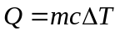to find the heat that would raise the temperature of the student’s body 7 ℃.
1W = 1J/s
Find Q to raise the body temperature from 37℃ to 44℃.
Q=mcΔT=(70 kg)(3480 J/kg·K)(7 ℃) = 1.7×10⁶ J
t = (1.7×10⁶ J)/(1200 J/s)=1400 s = 23 min.
Heat removal mechanisms are essential to the well-being of a person.

3-2 The atmosphere of Mars is mostly CO₂ (molar mass 44.0 g/mol) under a pressure of 650 Pa, which we shall assume remains constant. In many places the temperature varies from 0.0℃ in summer to -100℃ in winter. Over the course of a martian year, what are the ranges of (a) the root mean square speeds of the CO₂ molecules, and (b) the density in mol/m³ of the atmosphere?

Solution:
(a) 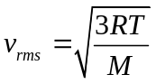
For T=0.0℃=273.16 K, 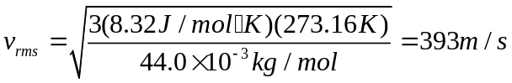
For T=-100.0℃=173.16 K, 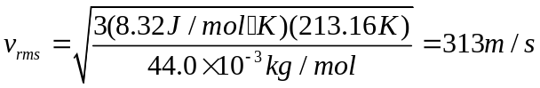
The range of speeds is 393 m/s to 313 m/s.
(b) PV=nRT gives 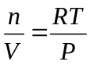
For T=273.16 K, 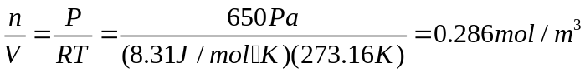
For T=173.16 K, 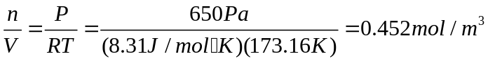

3-3 The Stirling cycle is similar to the Otto cycle, except that the compression and expansion of the gas are done at constant temperature, not adiabatically as in the Otto cycle. The Stirling cycle is used in external combustion engines (in fact, burning fuel is not necessary; any way of producing a temperature difference will do – solar, geothermal, ocean temperature gradient, etc.), which means that the gas inside the cylinder is not used in the combustion process. Heat is supplied by burning fuel steadily outside the cylinder, instead of explosively inside the cylinder as in the Otto cycle. For this reason Stirling cycle enginges are quieter than Otto cycle engines, since there are no intake and exhaust valves (a major source of engine noise). While small Stirling engines are used for a variety of purposes, Stirling engines for automobiles have not been successful because they are larger, heavier, and more expensive than conventional automobile engines. In the cycle, the working fluid goes through the following sequence of steps:

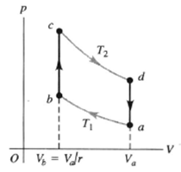

(1) Compressed isothermally at temperature T₁ from the initial
state a to state b, with a compression ratio r.
(2) Heated at constant volume to state c at temperature T₂.
(3) Expanded isothermally at T₂ to state d.
(4) Cooled at constant volume back to the initial state a.
Assume that the working fluid is n moles of an ideal gas (for which C_{v} is independent of temperature).
(a) Calculate Q, W, and ΔU for each of the processes a → b, b → c, c → d, and d → a.
(b) In the Stirling cycle, the heat transfers in the processes b → c and d → a do not involve external heat sources but rather use regeneration. The same substance that transfers heat to the gas inside the cylinder in process b → c also absorbs heat back from the gas in the process d → a.
Hence the heat transfers Q_{b→c} and Q_{d→a} do not play a role in determining the efficiency of the engine. Explain this last statement by comparing the expressions for Q_{b→c} and Q_{d→a} calculated in part (a).
(c) Calculate the efficiency of a Stirling cycle engine in terms of the temperatures T₁ and T₂. How does this compare to the efficiency of a Carnot cycle engine operating between these same two temperatures? (Historically, the Stirling cycle was devised before the Carnot cycle.) Does this result violate the second law of thermodynamics? Explain. Unfortunately, actual Stirling cycle engines cannot achieve this efficiency due to problems with the heat transfer processed and pressure losses in the engine.

Solution:
(a) Process a → b : For the isothermal process, ΔT= 0 and ΔU= 0,
W= nRT₁ln(V) 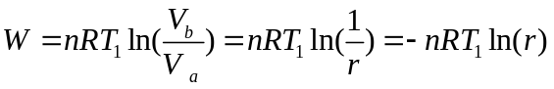
Q=W= -nRT₁ln(r)
Process b → c : For the isochoric process, ΔV = 0 and W = 0,
Q = ΔU = nC_{v}ΔT = nC_{v}(T₂ – T₁).
Process c → d : As in the process ab, ΔU = 0 and W = Q = nRT₂ln(r).
Process d → a : As in process bc, ΔV = 0 and W = 0; ΔU = Q = nC_{V}(T₁-T₂).
(b) The values of Q for the processes are the negatives of each other.
(c) The net work for one cycle is
W_{net} = nR(T₂-T₁)ln(r),
and the heat added (neglecting the heat exchanged during the isochoric expansion and compression, as mentioned in part (b)) is Q_{cd} = nRT₂ln(r).
The efficiency is 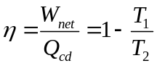.
This is the same as the efficiency of a Carnot cycle engine operating between the two temperatures.
For a Carnot cycle two steps in the cycle are isothermal and two are adiabatic and all the heat flow occurs in the isothermal processes. For the Stirling cycle all the heat flow is also in the isothermal steps, since the net heat flow in the two constant volume steps is zero.

3-4 A certain brand of freezer is advertised to use 730 kW·h of energy per year. (a) Assuming the freezer operates for 5 hours each day, how much power does it require while operating? (b) If the freezer keeps its interior at a temperature of -5.0℃ in a 20.0℃ room, what is its theoretical maximum performance coefficient? (c) What is the theoretical maximum amount of ice this freezer could make in an hour, starting with water at 20.0℃? The specific heat for water is C_{water}=4190 J/ kg·K and the latent heat of water into ice is L=334×10³ J/kg.

Solution:
(a) In one year the freezer operates (5h/day)(365day)=1825 h
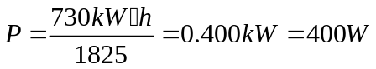
(b) Coefficient of performance 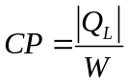, |Q_{L}| is the heat removed from the water to convert it to ice. The theoretical maximum 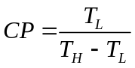.
T_{L}=-5.0℃=268.16 K, T_{H}=20.0℃=293.16 K,
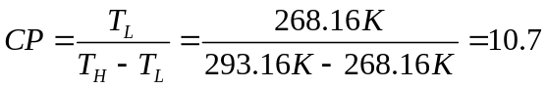
(c) W=P·t =(400W)(3600s)=1.44×10⁶ J
|Q_{L}|=CP·W=1.54×10⁷ J
|Q_{L}|= mC_{water}ΔT+mL
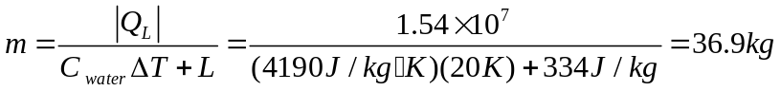

3-5 A 1.50 kg mass on a spring has displacement as a function of time given by the equation
.
Find (a) the time for one complete vibration; (b) the force constant of the spring; (c) the maximum speed of the mass; (d) the maximum force on the mass; (e) the position, speed, an acceleration of the mass at t=1.00 s; (f) the force on the mass at that time.

Solution:
From x(t) given in the problem, it is found that A=7.40 cm, ω=4.16 rad/s, and Ф=-2.42 rad.
(a) T = 2π/ω = 2π/ 4.16 rad/s = 1.51 s
(b) k=mω² = (1.50 kg)(4.16 rad/s)² = 26.0 N/m
(c) v_{max} =ωA=(4.16 rad/s)(7.40 cm)=30.8 cm/s
(d)F_{x} = -kx so F=kA=(26.0 N/m)(0.0740 m)=1.92 N
(e) x(t) evaluated a t=1.00 s gives
x=-0.0125m.
v_{x} =-ωAsin(ωt+Ф)=30.4 cm/s.
a_{x} =-kx/m = -ω²x = 0.216 m/s²

3-6 The following figure shows the wave shape of a sinusoidal wave traveling to the right at two instants of time. What is the mathematical representation of this wave?

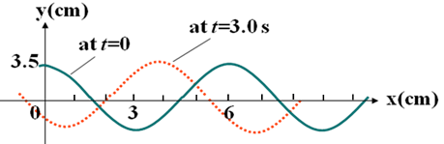

Solution:
From the figure we see that
A=3.5 cm, and λ=6.0 cm
Since at t=0, y=0 is at x=1.5 cm, and at t=3.0s, y=0 is at x=5.5 cm
Therefore the velocity of the wave is
u = (5.5 cm – 1.5 cm)/(3.0s) = 1.33 cm/s
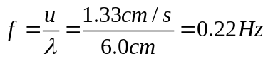
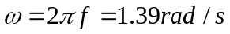
We also see that at t=0 the displacement y is maximum at x=0. So if we use a cosine function the initial phase angle Ф=0.
The wave is moving to the right. So,
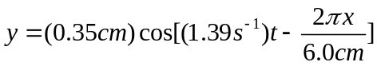

CDABDBDA

